Autonomous Indoor Garden

Thanushanth Kanagarajah

Department of computer science and engineering, University of Moratuwa

[Thanushanth.20@cse.mrt.ac.lk](mailto:Thanushanth.20@cse.mrt.ac.lk)

# Introduction

The Autonomous Indoor Garden is a cutting-edge horticultural innovation that combines technology and nature to create an intelligent and self-sustaining ecosystem. This project employs a range of hardware components, including Arduino, ESP32, moisture and temperature sensors, a 12V pump, and relays, to manage the garden's crucial parameters. The system autonomously regulates water levels by pumping water as needed, ensuring optimal soil moisture.

In addition, it continuously monitors and adjusts the temperature within the garden, creating the ideal environment for plant growth. A web-based user interface, developed using Node.js for the backend and a frontend web app, allows users to remotely access real-time data on temperature, water levels, and soil ph. Furthermore, manual control options enable users to customize their garden's conditions via the web app.

An emergency power backup system automatically activates in the event of a power failure, ensuring uninterrupted operation. This groundbreaking Autonomous Indoor Garden not only simplifies indoor gardening but also serves as a remarkable example of technology enhancing our connection with the natural world.

# Methods and Materials

# Methods

Our system revolves around the ESP32 Dev Module, serving as the heart of the project. It interfaces with soil moisture and temperature sensors, constantly monitoring the environment. When the soil moisture levels dip below a certain threshold, the ESP32 triggers a relay, activating the 12V water pump. This ensures that our indoor garden maintains the ideal moisture levels for plant growth.

The ESP32 also maintains a permanent Wi-Fi connection, enabling it to send real-time data to the cloud. Users can conveniently access this data through a web-based dashboard, allowing them to keep an eye on temperature, soil moisture, and other vital parameters. The interface even features a water control button, enabling users to initiate HTTP requests that reach the ESP32. This, in turn, allows them to manually manage the water system through relay control.

We have incorporated an emergency power system. We've connected a relay to both the backup battery and the primary power source. If a power outage occurs, the Arduino Uno detects it and sends a signal to another relay, seamlessly transitioning the system to the backup power source. This guarantees uninterrupted operation even during power disruptions.

## Materials

* ESP32 Dev Module
* Arduino Uno
* Soil Moisture Sensor
* Temperature Sensor
* 5VDC Relay Switch Module
* 12V Water Pump
* Resistors

This holistic implementation melds hardware and software to create a sophisticated autonomous indoor garden that's user-friendly, data-driven, and robust against power interruptions, catering to the needs of modern indoor horticulture.

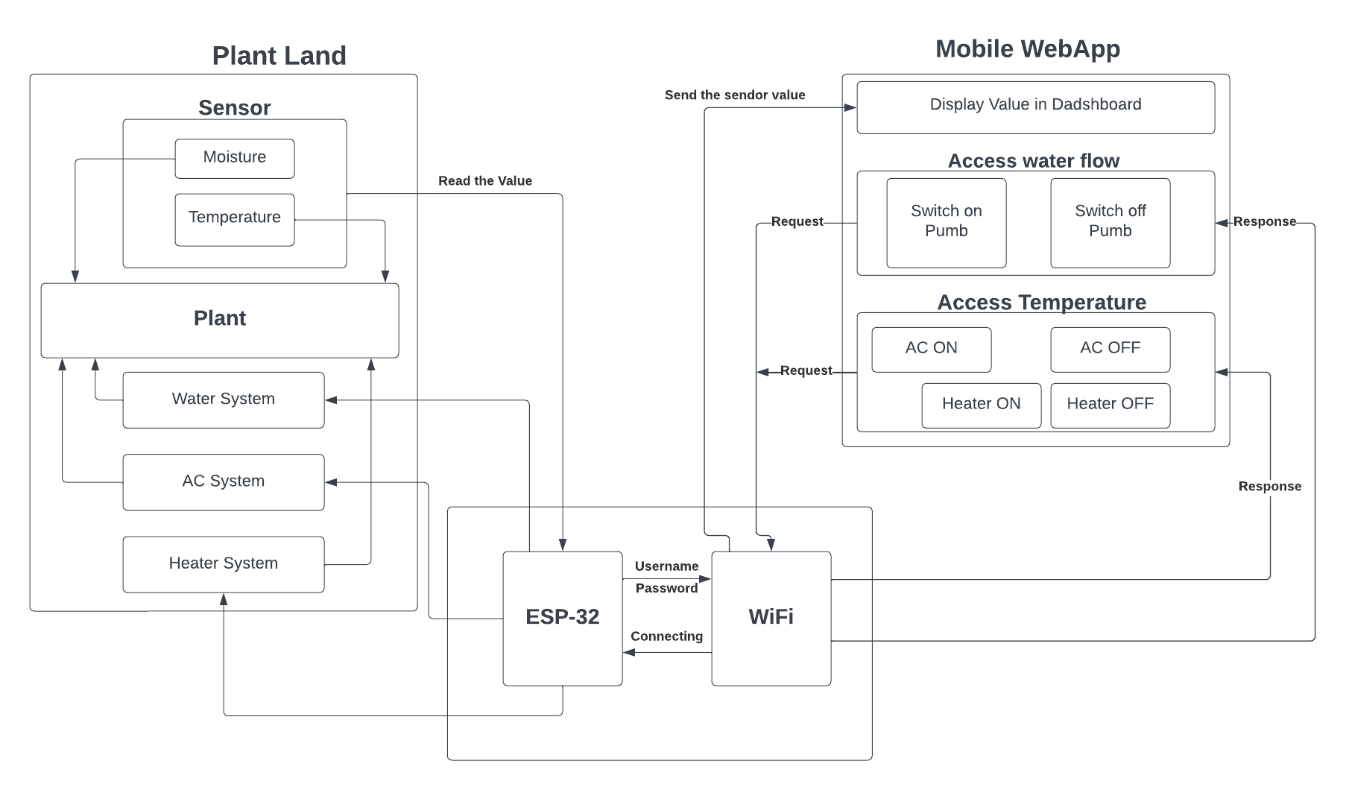

# Testing and validation

In the development of our Autonomous Indoor Garden system, a rigorous process of testing and validation is integral to ensuring its robust performance. The various sensors, including soil moisture and temperature sensors, underwent thorough calibration before deployment. Our system employs a comprehensive circuit diagram. Two distinct types of micro controller, the Esp 32 and Arduino Uno, were utilized to manage specific tasks, with the former overseeing the DC control and the latter serving as the power meter.

Power consumption of some individual system components.

|  |  |  |  |  |
| --- | --- | --- | --- | --- |
| Modules | Voltage | Current(A) | Power(W) | Power Consumption (kWh) per month |
| Moisture Sensor | 5 V DC | 50×10-3 | 0.25 | 0.18 |
| Temperature Sensor | 5 V DC | 1.5×10-3 | 7.5×10-3 | 0.0054 |
| Water pump | 12 V DC | 0.7 | 8.4 | 0.0042 |
| Relay 1 | 5 V DC | 60×10-3 | 0.3 | 0.216 |
| Relay 2 | 5 V DC | 60×10-3 | 0.3 | 0.216 |
| Total monthly power consumption (kWh) | | | | 0.6216 |

# Results

## Web App

The system was designed to get the data from the sensors and collect it in a central microcontroller and send it to IoT platform. IoT platform can store, analyze and preview the data to the user in private or public web-interface and in a mobile application. The web-interface can be visualized anytime from smart phone or computer and the mobile application is also a simple and easily accessible solution. Below image, a sample web-interface is shown. A chart with a meter and text

## Major Contribution to Power Efficiency

A significant milestone in our project lies in the development of a power-efficient solution for continuous monitoring and control within our Autonomous Indoor Garden system. As highlighted in the data table, our system boasts a remarkable monthly power consumption of 0.6216 kWh, showcasing its energy-conscious design. Moreover, we have integrated battery charging and accounted for the power consumption of the router in our system's operation, further exemplifying our commitment to energy efficiency.

## Future Prospects and System Enhancement

Looking ahead, we envision future enhancements to our system, particularly in the realms of air conditioning and ventilation (AC) and advanced control systems. These updates are detailed in the results section of our project, reflecting our ongoing commitment to refining and expanding the capabilities of our autonomous indoor garden. By addressing the control of environmental parameters like temperature and air circulation, we aim to provide users with an even more comprehensive and efficient indoor gardening experience, fostering healthier and more vibrant plants

# Conclusion

The development of our Autonomous Indoor Garden project has culminated in a sophisticated and efficient horticultural solution that seamlessly blends technology and nature. Through the integration of various hardware components, including Arduino boards, soil moisture and temperature sensors, dosing pumps, and relays, we have successfully created an autonomous indoor gardening system that can adapt to changing environmental conditions.

The system's web-based interface offers users real-time data on temperature, soil moisture, and pH levels, allowing for remote monitoring and control. This user-friendly approach empowers individuals to nurture their plants with precision, enhancing the overall indoor gardening experience. The incorporation of an emergency power system ensures uninterrupted operation during power outages, underscoring the system's resilience. Our rigorous testing and validation procedures further guarantee the reliability and accuracy of our technology.

Our Autonomous Indoor Garden represents a harmonious fusion of technology and nature, offering a smart and user-centric solution for indoor gardening enthusiasts. Its ability to adapt to changing conditions, coupled with user-friendly control.